BUSINESS PLAN FOR FIVE YEARS FROM 2026-2031 OF ENTERPRISE HUB AFRICA COMPANY LIMITED
P.O BOX 405
MAKAMBAKO-NJOMBE



drawn by,
Yunus .J. Mgumbwa
Email: mgumbwayunus3@gmail.com
Phone: +255760999735

Table of Contents
1. EXECUTIVE SUMMARY 1
1.1. Business description………………………………………………………………………………………………… 1
1.2. vision statement………………………………………………………………………………………………1
1.3. mission statement……………………………………………………………………………………………………….
1.4. core values………………………………………………… ………………………………………………..
1.5. business objectives…………………………………………………………………………………………………..
2. company profile 4
2.1. company name and registration…………………………………………………………………………
2.2.nature of business…………………………………………………………………………………………………
2.3. company location………………………………………………………………………………………………
2.4. ownership structure………………………………………………………………………………………
2.5. organization structure………………………………………………………………………………
3. product/services 4
3.1. construction and building materials………………………………………………………………………….
3.2. transportation services……………………………………………………………………………………………
3.3. real estate business …………………………………………………………………………………………….
3.4. agricultural products and raw materials trading …………………………………………
3.5. business consultation……………………………………………………………………………..
4. market analysis 4
4.1. industrial overview……………………………………………………………………………………………….
4.2. target market…………………………………………………………………………………………………….
4.3. market needs …………………………………………………………………………………..
4.4. competitive analysis………………………………………………………………………………………..
4.5. swot analysis…………………………………………………………………………….
5. marketing strategy 4
5.1. marketing objectives………………………………………………………………………………………..
5.2. pricing strategy………………………………………………………………………………………………………………..
5.3. promotion and advertising ……………………………………………………………………………………………..
5.4. sales strategy……………………………………………………………………………………………………………………
5.5. customer relationship management ……………………………………………………………………………
6. operation plan 4
6.1. business operations ………………………………………………………………………………………
6.2. office and warehouse requirement ……………………………………………………………
6.3. equipment and tools……………………………………………………………………………………….
6.4. supply chain management ……………………………………………………………………………….
6.5. quality control measures ……………………………………………………………………………
7. management and human resources 4
7.1. management team ……………………………………………………………………………………………………..
7.2. staff requirements …………………………………………………………………………………………………..
7.3. roles and responsibilities ………………………………………………………………………………………….
7.4. recruitment plan ……………………………………………………………………………………………………..
7.5. training and development ……………………………………………………………………………………. 3
8. financial plan 4
8.1. start-up capital requirement ………………………………………………………………………………………..
8.2. sources of capital …………………………………………………………………………………………………………….
8.3. revenue projections ………………………………………………………………………………………........................
8.4. projected income statement …………………………………………………………………………………………
8.5. projected balance sheet…………………………………………………………………………………………………
8.6. projected cash flow statement…………………………………………………………………………………….
8.7. break even analysis …………………………………………………………………………………………………………
8.8. profitabiulity analysis …………………………………………………………………………………………………..
9. risk management…………………………………………………………………………………………………..
9.1. Business risks ………………………………………………………………………………………………………….
9.2. Financial risk ………………………………………………………………………………………………………….
9.3. Operational risks………………………………………………………………………………………………………..
9.4. RISK MITIGATION STRATEGIES ………………………………………………………………………………………………………
10. legal and regulatory requirements ………………………………………………………………………
10.1. business registration ……………………………………………………………………………………….
10.2. licensing and permits ………………………………………………………………………………………
10.3. tax compliance ………………………………………………………………………………………………..
10.4. insurance requirements …………………………………………………………………………………
11. sustainability and growth strategy ………………………………………………………………….
11.1. expansion plan ……………………………………………………………………………………………….
11.2. strategic partnerships …………………………………………………………………………………..
11.3. technology integration …………………………………………………………………………………
11.4. corporate social responsibility …………………………………………………………………….
12. conclusion and recommendations ……………………………………………………………………
13. appendices ……………………………………………………………………………………………………..
13.1. company certificates ……………………………………………………………………………………..
13.2. financial tables …………………………………………………………………………………………….
13.3. organizational charts …………………………………………………………………………………..
13.4. supporting documents ………………………………………………………………………………….. 6

- Executive Summary
NEXORA GROUP LIMITED is a dynamic enterprise positioned as a key player in the importation and distribution sector, commercial Agriculture, agro-processing, construction and real estate, transport and logistics and business consultation in Tanzania. With a primary focus on delivering high-quality products and services, our business aims to cater to the diverse and evolving needs of the Tanzanian market. As a forward-thinking company, we are committed to providing solutions that leverage both local and international best practices, ensuring that our operations not only meet market demands but also contribute to the economic development of our Community.

  - Business Description
At NEXORA GROUP LIMITED, we understand that every project is unique and we tailor our approach to meet specific client needs. As an importation and distribution business, we pride ourselves on sourcing and offering premium imported goods, ranging from construction supplies to everyday household items. Our customers can easily access our products both online and at our conveniently located Makambako store.
Our business encompasses various sectors which allow us to effectively cater to different aspects of the Tanzanian economy. Through our agriculture segment, we provide high-quality fertilizers and agricultural tools tailored specifically for local farmers. Our real estate division offers extensive property listings covering diverse categories, from modern houses to agricultural plots. We also provide optimal storage solutions and aim to streamline operations with our cutting-edge logistics software designed for the agriculture and construction sectors. This diversification ensures that we are not only meeting our customers’ needs but are also creating a resilient business model capable of thriving in varying market conditions.
In addition to our importation services, we offer comprehensive construction services across Makambako, Njombe and beyond. We specialize in residential and commercial projects, always prioritizing quality and customer satisfaction. Our skilled team is dedicated to ensuring that every construction material we provide are of top-notch quality, consisting of essential items like concrete, roofing and insulation products for various building needs.
  - Vision Statement
To become African’s leading integrated business solutions company, driving sustainable economic growth through innovation, entrepreneurship, investment and strategic partnerships.
  - Mission Statement
To provide reliable, innovative and value-driven solutions in construction, transportation, real estate, agricultural trade and business consultancy, empowering individuals, businesses and communities across Africa to achieve sustainable growth and prosperity.

  - Core Values
- Integrity: we conduct business with honest, transparency and accountability
- Innovation: we embrace creativity and modern solutions to meet evolving market needs.
- Excellence: we strive for the highest standards in service delivery and customer satisfaction.
- Professionalism: we maintain competence, reliability and ethical conduct in all our operations.
- Partnership: we build strong and lasting relationships with clients, investors and stakeholders.
- Sustainability: we promote responsible business practices that create long-term economic and social value.
- Customer focus: we prioritize the needs and success of our clients in every decision we make.
  - Business objectives
Short term Objectives (1-3 years)
- Establish a strong market presence in Tanzania and neighboring countries
- Achieve annual revenue growth of at least 20%
- Build a diverse portfolio of clients across construction, transportation, real estate, agriculture and consultancy sectors.
- Develop strategic partnerships with suppliers, investors, financial institutions, and government agencies.
- Create employment opportunities for skilled and unskilled workers within the communities where the company operates.
- Implement efficient operational systems and modern technologies to improve productivity and customer service.
Medium-Term objectives (3-5 Years)
- Expand operations into multiple regions across Tanzania and selected African markets.
- Increase the company’s asset base through investments in transportation equipment, real estate properties and agricultural trading facilities.
- Become a recognized and trusted brand in business consulting and investment facilitation.
- Diversify revenue streams by introducing new products and services aligned with market demand.
- Strengthen financial sustainability through sound financial management and profitability business operations.
Long-Term Objectives (5-10 Years)
- Become one of African’s leading business development and investment companies.
- Establish a network of branches and strategic partnerships across key African markets
- Contribute significantly to economic development through investment, entrepreneurship, and job creation.
- Achieve sustainable profitability and maximize shareholder value.
- Promote innovation, environmental sustainability and corporate social responsibility in all business activities
- Position Enterprises Hub Africa as a preferred partner for local and international investors seeking opportunities in Africa.

- COMPANY PROFILE
  - COMPANY NAME AND REGISTRATION
The name of Company is NEXORA GROUP LIMITED
Legal Status
Private Limited Company
Registration status
Not yet to be registered
The company expecting to start registration process on early the month of July, 2026
  - Nature of business
Enterprises Hub Africa Limited is a diversified business company engaged in the provision of commercial, trading, and consultancy services aimed at supporting economic growth and business development in Tanzania and across Africa.
The Company’s core business activities include:
- Construction and Building Materials supply:
- Supply of construction materials such as cement, steel, roofing sheets, aggregates, paints and related products.
- Procurement and distribution of building materials to contractors, developers, institutions and individual customers.
- Support services for construction projects.
- Transportation and Logistics
- Transportation of goods and materials within Tanzania and neighboring countries
- Logistics coordination, cargo handling, and distribution services
- Vehicles leasing and transport support for businesses and projects
- Real Estate Services
- Purchase, sale, and leasing of land and properties
- Property management and real estate investment
- Real estate consultancy and market advisory services
- Agricultural Products and raw materials trading
- Buying and selling agricultural commodities such as maize, rice, beans, sunflower, sesame, coffee, cashew nuts, cloves and other crops.
- Supply of agricultural raw materials to processors, manufacturers and exporters
- Facilitation of market linkages between farmers and buyers
- Business Consultancy Services
- Business planning and development
- Market research and feasibility studies
- Financial and investment advisory services
- Business registration, compliance, and strategic management consulting

  - Company location
NEXORA GROUP LIMITED has its principal place of business in Makambako-Njombe Tanzania, located in southern part of Tanzania, famous commercial place in southern part
Registered office
Physical address: Sokoni
Ward: Makambako
District: Njombe
Region: Dar es salaam
Country: Tanzania

Strategic Advantage of the location
- Access to major transportation networks including roads and railways
- Proximity to suppliers, customers, financial institutions and government agencies
- Easy access to domestic and international markets
- Availability of skilled labor and business support services.
- Strong connectivity for construction, real estate, agricultural trade, transportation and consultancy operations.
Key Strategic Economic Areas
- Transport and logistic hub
TAZARA Railway forms the backbone of Transportation in Makambako
Infrastructure
- Bus terminal
- Truck terminal
- TAZARA Railway station
- Freight forwarding and cargo handling services
- Highway connections
- Cargo handling facilities
- Agricultural Trade Zone
This is the primary production and collection area for agricultural commodities from Makambako and surrounding districts such as Mbarali, Wanging’ombe, Njombe and Ludewa.
Key Products
- Maize
- Beans
- Potatoes
- Avocado
- Timber products
- Irish potatoes
- Vegetables
- Warehousing and grain Storage Area
- Facilities
- Grain silos
- Agricultural warehouses
- Commodity storage centers
Importance
This zone reduces post-harvest losses and stabilizes food supply chains
Opportunities
- Warehouse leasing
- Commodity trading
- Food reserve management
- Cold-chain logistics
- Real Estate Development zone
- Development Areas
- Residential estates
- Commercial buildings
- Industrial plots
- Mixed-use developments
Investments Potential
- Housing projects
- Rental apartments
- Shopping centers
- Industrial parks
Population growth and business expansion continue to increase demand for land and buildings
- Construction Materials Hub
The repaid growth of Makambako creates strong demand for construction materials.
Main Products
- Cement
- Steel
- Roofing
- Electrical materials
- Paints and finishing products
Business potential
- Hardware supermarkets
- Construction equipment rental
- Building materials distribution
- Real estate development

- Commercial Business District (CBD)
The CBD serves as the commercial heart of Makambako.
Main Activities
- Banking services
- Retail trade
- Hotels and accommodation
- Business support services
- Insurance services
- Government officers
- Wholesale trade
Strategic importance
The CBD connects producers, traders, transporters, and consumers, making it the main center for business transactions.
- Business Consultancy and Enterprise Development Sector
The sector can be positioned near the CBD and Service Sector Zone because it supports all economic activities in Makambako
Core services
- Business registration and licensing
- Business plan development
- Feasibility studies
- Market research and analysis
- Financial planning and budgeting
- Tax and regulatory compliance support
- Investment advisory services
- Project management
- Training and capacity building
- Entrepreneurship development

Target clients
- SMEs and startups
- Farmers and cooperatives
- Transport and logistics companies
- Construction firms
- Real estate developers
- Investors
- Government projects
- NGOs and development partners

Investments opportunities
- Business incubation center
- Entrepreneurship training academy
- Digital business support center
- Investment facilitation office
- Research and innovation hub

Economic contribution
This sector acts as the knowledge and innovation hub that supports all other sectors by improving business efficiency, access to finance, and investment readiness.
No. | Sector | Strategic role
1 | Agricultural Trade Zone | Production, aggregation, and trading of agricultural products
2 | Transport and logistics Hub | Movement of goods and passengers
3 | Warehousing and grain storage | Storage and commodity management
4 | Real Estate Development | Housing and commercial property development
5 | Construction materials Hub | Supply of building materials
6 | Service Sector | Hospitality, finance, and retails services
7 | Business Consultancy and Enterprise Development | Business support, investment advisory, and entrepreneurship development

ENTERPRISE HUB AFRICA LTD, the business Consultancy and enterprise development sector can serve as the central coordinating unit that supports your activities in:
- Construction
- Transportation
- Real estate
- Agricultural products trading
- Investment facilitation
- Entrepreneurship development
- Project management services
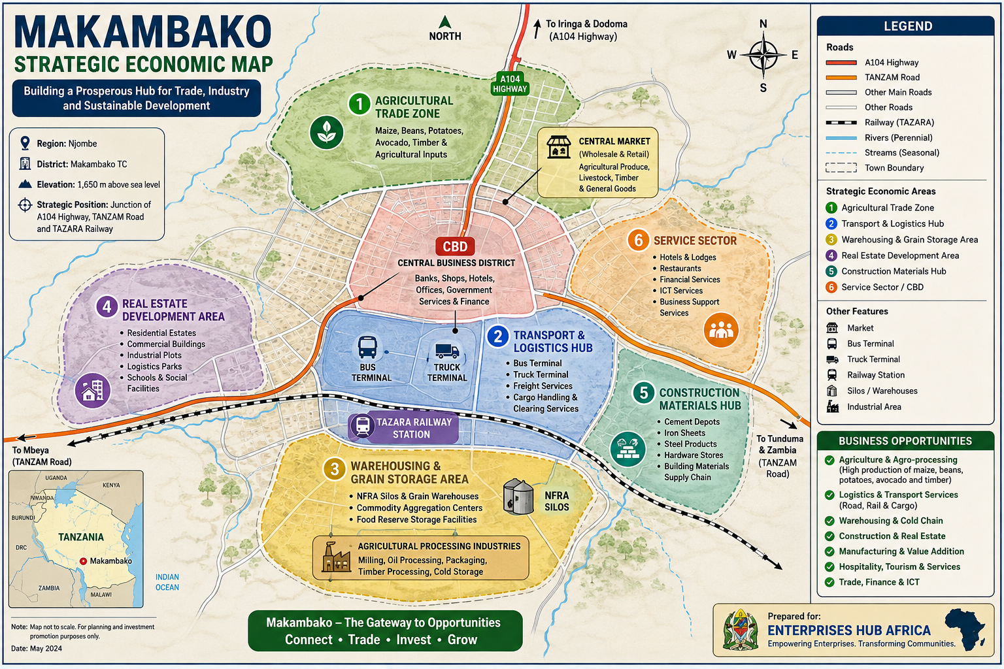

  - Ownership Structure
The Ownership Structure of shows how the company is owned and how shares are distributed among its shareholders. For a private limited company in Tanzania, ownership is usually divided into shares held by founders or investors. Shareholders are the legal owners of the company, while directors manage its daily operations.
Ownership Structure for Enterprises Hub Africa Limited
Shareholder | Position | Number of shares | Ownership (%)
Yunus J. Mgumbwa | Founder and Managing Director | 800 | 80%
Anna Badanga | Investor | 200 | 20%
 |  | 1,000 shares | 100%

Share Capital Structure
Authorized Share Capital: TZS 10,000,000
Total shares issued: 1,000 Ordinary Shares
Nominal Value Per Share: TZS 10,000
Total paid-up capital: TZS 2,000,000
Rights of Shareholders
- Voting rights at shareholders’ meetings
- Right to receive dividends when declared
- Right to participate in major company decisions
- Right to transfer shares subject to company regulations
- Right to inspect company records as provided by law
Board of Directors
Director | Position
Yunus Mgumbwa | Managing director
Masele Kwiligwa | Board member

  - Organization structure
Considering company’s business activities in construction materials, transportation, real estate, agricultural products and business consultancy.

Key Roles and Responsibilities
- Shareholders
- Owners of the company
- Approve major strategic decisions
- Appoint the Board of Directors
- Board of Directors
- Provides strategic guidance
- Oversees company performance
- Approves policies and annual budgets
- Managing Director
- Chief Executive Officer of the company
- Responsible for overall management and implementation of company strategies
- Finance and Accounts Manager
- Financial planning and budgeting
- Preparation of financial reports
- Tax and regulatory compliance
- Cash flow management
- Operations manager
Supervises all operational departments:
- Construction materials Division
- Transportation Division
- Real estate Division
- Agricultural products and Raw Materials Division
- Business Development Manager
- Leads consultancy services
- Identifies new business opportunities
- Develops partnerships and client relationships
- Oversees project proposals and tenders
- Marketing and sales manager
- Branding and promotion
- Customer acquisition and retention
- Marketing research
- Sales management
- Human Resource and Administration Manager
- Recruitment and staff development
- Employee welfare and performance management
- Office administration
- Policy implementation
Recommended initial Staffing (startup phase)
Position | Number
Managing director | 1
Finance officer/Accountant | 1
Operational officer | 1
Business Consultant | 1
Marketing and sales officer | 1
Administrative Assistant | 1
Drivers/field officers | 0
Casual workers | As needed
Total | - Employees
- Product and Service
Product and Services
Overview
At NEXORA GROUP LIMITED our core mission is to serve the Tanzanian market by offering high-quality imported goods and specialized services. Our focus is on ensuring that both individuals and businesses can access essential products and services seamlessly, whether through our online platform or our diverse offerings are designed to cater to the unique needs of our customers, making us a reliable partner in various industries.
  - Targeted Audience
For NEXORA GROUP LIMITED which operates in construction, Transportation, Real Estate, Agricultural products and Business Consultancy, the target audience includes
- Business Owners and Entrepreneurs
- Startups seeking business registration and advisory services
- Small and medium Enterprises (SMEs)
- Growing companies needing strategic business support and market expansion advice.
- Real estate clients
- Individuals looking to buy, sell or rent properties
- Property investors
- Land owners and real estate developers
- Corporate organizations seeking commercial properties
- Construction Sector Clients
- Homeowners building or renovating houses
- Property developers
- Government institutions
- Schools, hospitals, and commercial building owners
- Contractors and construction companies
- Agricultural sector clients
- Farmers and farmer group
- Agricultural cooperatives
- Agro-dealers
- Food processing companies
- Exporters and importers of agricultural products
- Transportation clients
- Manufactures and wholesalers
- Agricultural dealers
- Construction companies requiring logistics services
- Retailers and distributors
- Individual customers requiring cargo transportation
- Financial Institutions and Development Organizations
- Banks
- Microfinance institutions
- NGOs supporting entrepreneurship and agriculture
- Development partners seeking consultancy services
- Government and Public Institutions
- Local Government Authorities
- Public procurement agencies
- Development projects requiring consultancy, transport, construction and agricultural services
Geographic Target Market
- Primary: Tanzania
- Secondary: Kenya, Uganda, Rwanda, Burundi and other East African markets
Ideal Customer Profile
Men and women aged 25-60 years, including entrepreneurs, investors, farmers, property owners, corporate executives and Government institutions looking for reliable business solutions, investment opportunities, logistics services, construction materials and professional consultancy services.

  - FINANCIAL OVERVIEW
NEXORA GROUP LIMITED anticipates strong financial performance in its first year of operation, with projected revenue of Tshs. 234,000,000. Our estimated total costs are Tshs. 63,400,000, resulting in a projected net profit of Tshs. 94,010,000. This positions our net profit margin at a healthy 23%, showcasing our commitment to efficient operational management and revenue generation. This financial foundation not only supports our business objectives but also equips us to reinvest in local communities through job creation and services enhancement.
In summary, NEXORA GROUP LIMITED is dedicated to becoming a leading entity in various sectors by prioritizing quality, customer satisfaction and community development. We invite stakeholders, investors and clients to join us in our journey of transforming the market landscape in Tanzania. Through our wide range of products and services, innovative solutions, and customer-centric approach, we aspire to set new benchmarks of excellence and reliability in all our endeavors.
Through a diverse offering that meets the needs of our targeted segments and an operational focus on innovation and community support, NEXORA GROUP LIMITED is well positioned for sustainable growth in the Tanzanian market.
Core Operations
- Importation and Distribution: we specialize in the importation of quality goods and services to meet the diverse needs of Tanzania consumers and businesses, ensuring that our distribution channels are reliable and efficient.
- Commercial Agriculture and Agro-processing: our agriculture branch focuses on sustainable farming practices and high-quality processing of agricultural products to drive food security and provide nutritious options for consumers.
- Construction and Real Estate: we offer services in the constructions sector, focusing on residential and commercial real estate projects that adhere to quality standards and promote sustainable development.
- Transport and Logistics: our logistics arm provides comprehensive transportation solutions that ensure goods are delivered in a timely and cost-effective manner, fostering trade and commerce throughout Tanzania.
- Business Consultation: we provide expert consultation services to startups and established businesses alike, assisting them in strategizing and optimizing their operations to achieve their business goals.
  - Business overview
Imported Goods
Our company takes pride in its extensive range of imported goods aimed at fulfilling the diverse requirements of the Tanzanian market. We understand that consumers and businesses alike seek quality and reliability, and that’s precisely what we provide.
Product range: from essential household items to critical construction supplies, our inventory is carefully curated to meet customer demands.
Quality assurance: we work only with trusted suppliers to ensure that all imported products meet high-quality standards.
Accessibility: customers can easily shop through our online store or visit our physical location, allowing for a flexible shopping experience.
Construction services
At NEXORA GROUP LIMITED we believe that every building tells a story, which is why we offer construction services tailored to both residential and commercial projects. Our professional approach ensures that your construction experience is smooth and rewarding.
Expertise: our skilled team brings years of experience in the construction industry, allowing us to handle projects of various scales and complexities.
Customer-centric Approach: we prioritize quality and customer satisfaction, working closely with clients to understand their needs and vision.
Convenience: whether you’re looking to connect with us online or visit our store, we make it easy for you to engage with our services.
Transport Solutions Construction materials
We specialize in delivering high-quality construction materials necessary for a variety of building projects. From residential homes to commercial buildings, our offerings ensure that your project runs smoothly from start to finish.
Diverse selection: our catalog includes essential materials such as concrete, roofing, and insulation products that cater to mall types of construction needs.
Quality products: we source our materials from reputable suppliers to guarantee durability and reliability.
Accessible shopping: customers can shop in-store at our Makambako location or browse through our online catalog, making ordering a hassle-free experience.

Offering a range of transport solutions, we cater to the logistical needs of businesses across Makambako Njombe and beyond. Our services are designed to ensure that your goods are transported safely and efficiently.
Comprehensive options: from freight forwarding to last mile delivery, we provide a full spectrum of transport services tailored to suit diverse business requirements.
Reliability: our commitment to safe and efficient transport ensures that your goods reach their destination on time and in perfect condition.
Booking convenience: customers can easily book their transport needs online or visit our physical location for personalized assistance.
The following are the construction materials
- Cement: used for binding bricks, blocks and concrete together
- Sand: used for plastering, concrete mixing and brick laying
- Gravel: small stones mixed with cement and sand to make concrete
- Bricks: used for building walls and structures.
- Steel bars (reinforcement Bars): used to strengthen concrete structures.
- Timber/Wood: used for roofing, doors, windows and formwork.
- Roofing sheets: used for covering roofs and protecting buildings from rain
- Grass: used for windows, doors, and decoration.
- Tiles: used for flooring and wall finishing.
- Paint: used for decoration and protection of walls.
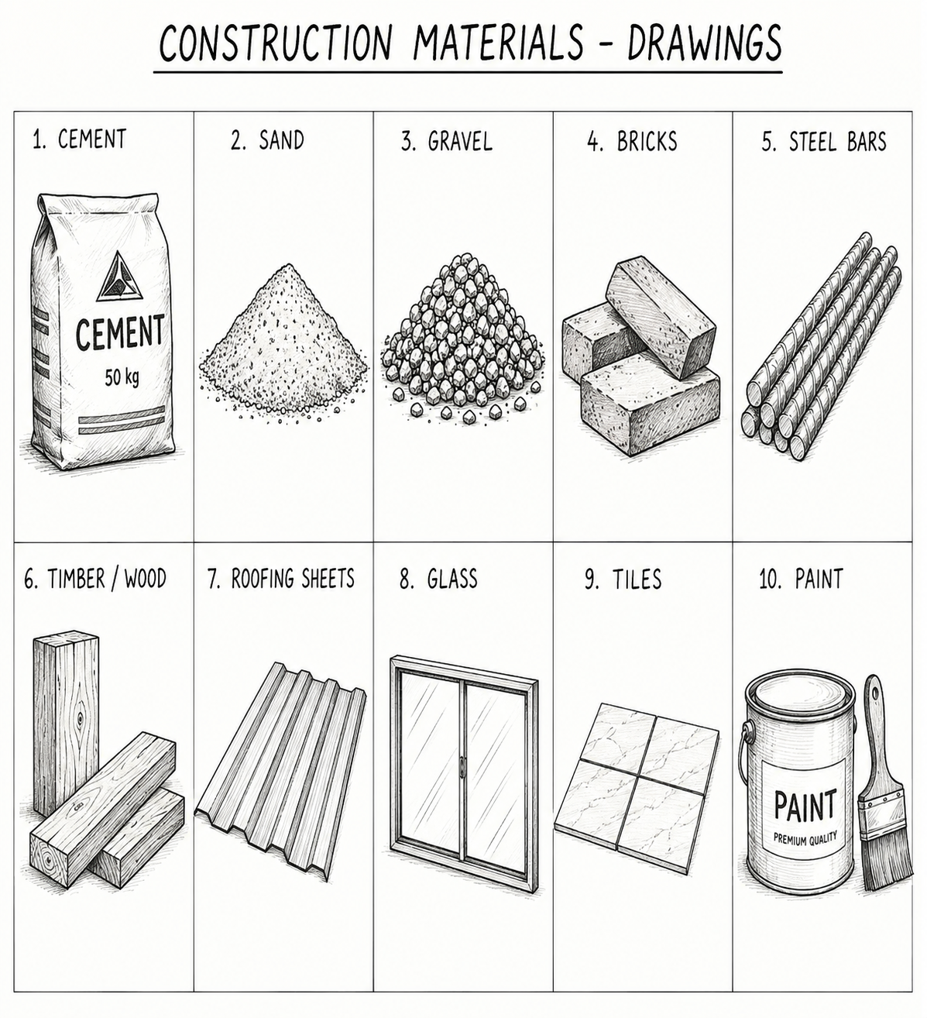

3.2. Real Estate Listings
Dreaming of finding the perfect property? Our comprehensive real estate listings offer everything from modern houses and commercial spaces to agricultural plots. Key features include:
- Diverse Property options: we cater to various needs, whether you’re looking for a cozy home, a business location, or a piece of land for farming.
- Personal assistance: customers can view our offerings online or visit us at our local office for personal assistance, ensuring they get the help they need in their property search.
- Regional focus: our real estate services target the Makambako and Njombe regional at large, along with all cities in Tanzania, allowing us to connect buyers with properties that suit their requirements.

3.3. Agricultural Raw Materials
Fertilizers
We specialize in providing top-notch fertilizers to boost agricultural productivity in Tanzania. Our selection includes:
- Slow-release Granules: these fertilizers are designed for sustained growth, providing essential nutrients to plants over an extended period. They help reduce nutrients leaching and improve soil health.
- Liquid Fertilizers: ideal for quick nutrient absorption, our liquid fertilizers deliver immediate nourishment to plants, promoting vigorous growth and increased yields.


- Organic Fertilizers: these come from plant or animal sources and improve soil structure


- Bio fertilizers: contain living microorganisms that enhance nutrient availability example rhizobium, azotobacter, blue-green algae

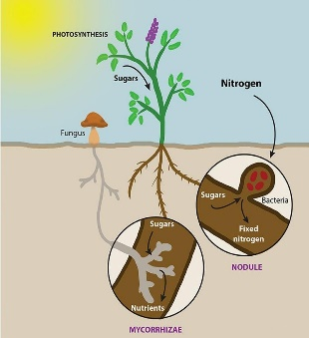

- Inorganic (Chemical) Fertilizers: Manufactured fertilizers with specific nutrient concentrations.
Examples
- Urea (nitrogen)
- DAP (diammonium phosphate)
- Potash fertilizers

With our fertilizers available for purchase at our store of through our online platform, we aim to support local farmers and businesses with the best agricultural solutions. Our products are perfect for anyone looking to enhance soil fertility and maximize crop production.
Storage solutions
If you’re ready to find your ideal property, look no further! Our storage solutions complement our real estate services with offerings such as
- Comprehensive Listings: we offer a wide range of properties, including contemporary homes, active commercial locations and spacious agricultural land.
- Accessibility: Customers can check out our selections online or visit our friendly office for a more hands-on experience, allowing for seamless property search process.
Our goal is to simplify the property searching experience and facilitate real estate transactions that are both efficient and satisfying for our clients.

Agricultural Tools
We are committed to helping farmers in Tanzania thrive by offering a variety of high-quality agricultural tools, such as:
- Hand Hoes: Essential for tilling and preparing soils, our hand hoes are durable and reliable, making them perfect for small-scale farming
- Plow sets: our plow sets
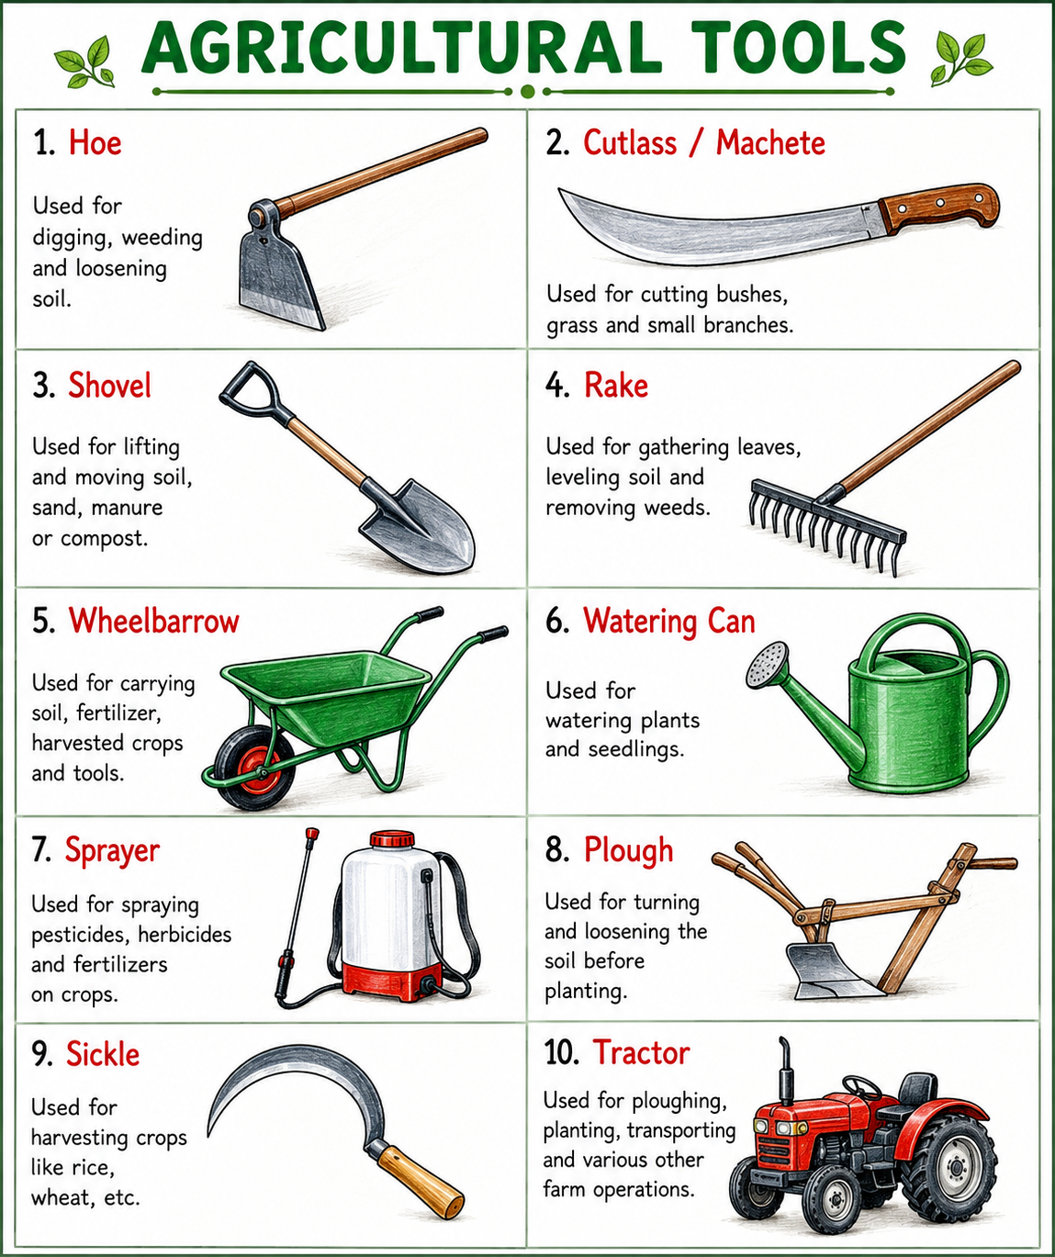

Conclusion
In conclusion, ENTERPRISE HUB AFRICA LIMITED is dedicated to delivering exceptional products and services through a customer-oriented approach. Our focus on quality, coupled with accessibility, positions us as a trusted partner in the importation, construction, and logistics sectors in Tanzania. We are excited to continue serving our community with integrity and excellence, ensuring that our customers can always find the best solutions for their needs.

MARKET ANALYSIS
Market Analysis
Overview of the Target Market
ENTERPRISE HUB AFRICA LIMITED operates in several key sectors, including importation and distribution, commercial agriculture and Agro-processing, construction and real estate, transport and logistics, and business consultation. Give the diversity of our offerings, we have a broad target market that encompasses various customer groups across Tanzania. Our primary focus is on providing essential services to agricultural business owners, construction workers and construction contractors. Our operation extends to both online platforms and a physical location in Makambako, Njombe, which facilitates access for customers across all cities in Tanzania.
Customer Segments
Customer Group 1: agricultural Business Owners
Our first customer segment consists of agricultural business owners, which includes both men and women aged between 25 to 54 years. This group primarily operates in the agricultural sector, facing daily challenges that influence their operations and profitability. Most of these owners fall under a low-income bracket, which means they are often price-sensitive and seek efficient, cost-effective solutions that help them increase productivity and optimize their processes. They rely heavily on our services and products to improve their agricultural output and ensure the sustainability of their businesses.
Customer Group 2: construction Workers
The second customer segment includes construction workers, who are predominantly men aged between 25 to 50 years. This group typically falls within a medium-income level, working on various construction projects throughout Tanzania. They seek reliable services and products that can support their work from materials needed for construction projects to transportation for tools and equipment.
Additionally, they appreciate businesses that provide flexible pricing and financing options, making it easier for them to manage their expenses while maintaining quality in their projects.
Customer Group 3: construction Contractors
The final customer segment comprises construction contractors, generally men aged between 35 to 64 years, also categorized as medium-income earners. This group is key to our business as they often serve as intermediaries, relying on us for the supply of materials and services essential for projects completion. They value dependable suppliers who can meet deadlines and provide high quality products.
Understanding their projects timelines and operational needs is crucial for fostering long term relationships and securing repeat business.
Market Needs
Each of our customer segments has specific needs that ENTERPRISE HUB AFRICA LIMITED is positioned to address;
Affordability: the low-income agricultural business owners require cost-effective solutions that enable them to enhance their productivity without stretching their limited budgets.
Accessibility: both physical and online access to our services ensures that customers from various locations can benefit from what we offer. This is particularly vital for those in remote areas who may struggle to find similar services.
Quality of service: as our three customer groups regularly rely on the products and services provided, maintaining high quality is a non-negotiable aspect that affects customer satisfaction and loyalty.
Timely delivery: meeting deadlines for construction projects and agricultural cycles is critical, emphasizing the need for efficient transport and logistics solutions.
Support and Consultation: providing business consultation services can help our customers make informed decisions, especially the agricultural business owners and construction contractors, regarding best practices and operational efficiencies.
In conclusion, the market landscape for ENTERPRISE HUB AFRICA LIMITED presents ample opportunity across our targeted customer segments. By adopting a customer-centric approach and continuously tailoring our services to meet the unique needs of agricultural business owners, construction workers and solidify our reputation in the market. The interplay between our diverse offerings and the specific demands of each customer group ensures that we can continually adapt and thrive in the competitive landscape of Tanzania.

Competitor Analysis
Competitive Analysis
Market overview
In the landscape of service-oriented businesses such as importation and distribution, commercial agriculture, agro-processing, construction and real estate, transport and logistics, and business consultation, competition is fierce. Companies in these sectors typically focus on providing quality services that cater to diverse customer needs while navigating challenges like brand recognition and market reach. ENTERPRISE HUB AFRICA LIMITED seeks to carve out its niche through a strategic approach that capitalizes on our strengths while addressing our weaknesses.
Success Drivers
ENTERPRISE HUB AFRICA LIMITED has identified key success drivers that will facilitate our competitive advantage in the market:
Diverse product range for various customer needs: our extensive offerings allow us to target different market segments, ensuring we meet the varied demands of our customers. This diversity not only attracts a broader clientele but also enhances our resilience against market fluctuations.
Strong focus on quality and customer satisfaction: we believe that prioritizing quality in our service delivery will foster customer loyalty and positive word of mouth referrals. Satisfied customers are likely to return and recommend our services, thereby strengthening our market position.
Skilled team ensures smooth construction experiences: the expertise of our skilled workforce is instrumental in guaranteeing timely and quality project completion. Our team’s experience in the construction industry enables us to navigate potential challenges effectively, providing a seamless experience for our clients.

Competitive Advantages
To stand out in the competitive landscape we leverage the following advantages:
Advantage | Description
Comprehensive service offering | By providing a range of services, from importation to consultation, we are equipped to serve multiple customer needs under one roof, simplifying the procurement process for our clients.
Customer- centric Approach | We prioritize customer feedback to refine our services continually which fosters trust and builds lasting relationships.
Expertise in Local Market Dynamics | Our understanding of the local markets ensures that we can tailor solutions to cater specifically to the needs of African businesses, distinguishing us from international competitors who may not have this insight.

Areas of Challenges
Despite our strengths, ENTERPRISE HUB AFRICA LIMITED must navigate certain weaknesses that could hinder our growth and competitiveness:
Limited brand recognition in a competitive market: as a newer entity, establishing strong brand presence is vital. Without recognizing branding, attracting new clients may be challenging, especially against established competitors.
Limited workforce for handling large scale operations: our current workforce may not suffice for large projects, limiting our ability to compete on significant contracts and affecting our growth trajectory.
Narrow market reach due to limited marketing resources: effective marketing is crucial in garnering customer interest and informing potential clients about our offerings. With constrained marketing budgets and resources, expanding our reach may take longer than projected.
Strategic Recommendations
To navigate the competitive landscape successfully, ENTERPRISE HUB AFRICA LIMITED should consider the following strategies
- Establish a robust brand identity and invest in marketing initiatives to enhance brand visibility.
- Expand our recruitment efforts to build a capable workforce that can manage large-scale projects, ensuring we don’t miss out on lucrative contracts.
- Utilize digital marketing solutions to broaden our market reach, targeting diverse segments through social media and online advertising.
Conclusion
In conclusion, while ENTERPRISE HUB AFRICA LIMITED exhibits several strengths that provide a competitive advantage in the service sector, it must also address key weaknesses to ensure sustainable growth. By focusing on enhancing brand recognition, expanding workforce capabilities and optimizing marketing strategies, we can effectively position ourselves as a leading service provider in our target markets.

Marketing strategy
Marketing and sales Strategy
Marketing channels
To effectively reach our target customers like agricultural business owners, construction workers and construction contractors in Makambako-Njombe and other cities in Tanzania.
We will utilize a multifaceted marketing approach. Our marketing channels will include:
- Social media: leveraging platforms like Facebook and Instagram to showcase our products, services and customer testimonials. Regular posts, engaging stories and targeted ads will help in building brand awareness and community engagement.
- Email Marketing: developing a mailing list potential and existing customers will allow us to share updates, promotions and newsletters directly to their inboxes, keeping our brand top-of-mind.
- Search Engine Optimizing (SEO): Optimizing our website with relevant keywords related to importation, construction services and transport solutions will improve our online visibility and attract organic traffic.
- Physical Advertisements: utilizing brochures and posters in strategic locations around Makambako, especially in agricultural and construction zones, to reach our target markets directly.
Sales Strategy
Converting leads into customers is crucial for our business growth. Our sales strategy will encompass:
- Personalized Customer Engagement: our small team will actively engage with customers both online and at our physical store at Makambako. By providing tailored solutions that suit individual needs, we can create a stronger connection with potential buyers.
- Demonstrations and Trials: offering free trials or showcasing our construction services in real-time will allow potential clients to gauge the quality of our work before committing. This can enhance trust and facilitate sales conversions.
- Streamlined Sales Process: we will establish a straightforward and efficient sales process, including easy online ordering and seamless booking system for our transport solutions. Simplifying these steps will encourage more customers to complete their purchases.
Customer Acquisition and Retention
Attracting new customers and retaining existing ones is pivotal for sustainable growth. Our strategies will include;

- Incentives for New Customers: we will offer promotional discounts or packages for first time customers, making it attractive for them to choose our services.
- Loyalty Programs: implementing loyalty programs that reward repeat customers will encourage continuous engagement and purchases. Points or discounts on future services will keep clients coming back.
- Feedback Mechanism: regularly collecting feedback from customers will provide insights that can improve our offerings and customer experience. Addressing concerns swiftly can foster loyalty and satisfaction.
Pricing Strategy
We position our pricing strategically to remain competitive while also catering to our target customer groups:
- Value-Based Pricing: we will base our pricing on the perceived value of our quality products and services to our customers, particularly emphasizing our diverse range and skilled team.
- Competitive Analysis: conducting regular assessments of competitors’ pricing will help us stay aligned with the market while ensuring we maintain the quality of our offerings.
- Affordable Options: considering our target customers’ income levels, we will ensure that our prices are aligned with their purchasing power, offering low to medium priced options without compromising quality.
Alignment with Business Goals
Our marketing efforts will directly support our business objectives by:
- Enhancing Brand Recognition: through targeted marketing and social media presence, we aim to overcome our limited brand recognition and position ENTERPRISE HUB AFRICA LIMITED as a trusted name in the marketplace.
- Expanding market reach: as our products are promoted across multiple channels, we expect to broaden our market reach, which aligns with our goal of becoming a key player in the sectors of Importation, construction and logistics.
- Maximizing customer satisfaction: with a focus on quality and customer service, we aim to establish long-lasting relationships with customers, enhancing our reputation and encouraging word-of-mouth referrals.
By employing these strategies, we will effectively cater to the diverse needs of our customers while ensuring our business continues to grow and thrive in Tanzania.

Operational Plan
Operational plan
Day-to-Day Operations
At ENTERPRISE HUB AFRICA LIMITED, our daily operations are centered around providing unparalleled service in importation and distribution, commercial agriculture and agro-processing, construction and real estate, transport and logistic and business consultation. Each operation is designed to ensure efficiency and responsiveness to market demands.
The daily process begins with our online platforms and physical locations serving customers in Makambako, Njombe and all cities of Tanzania. We prioritize customer interaction, utilizing both digital communications and face-to-face meetings to facilitate sales and service delivery. Our team utilizes a streamlined workflow to manage orders and logistics, ensuring timely delivery of goods and services.
Technology plays a crucial role, where we deploy systems for inventory management and customer relationship management (CRM). This helps us track sales, manage stock levels and maintain strong customer relationships. By employing tools such as spreadsheets for data analysis and project management software for oversight, we ensure that our operations run smoothly and allow us to react promptly to customer needs.
Staffing
Our current team consists of three talented individuals, each bringing unique skills to the table;
- Operations manager: this individual oversees all daily operations from logistics to customer service, ensuring that operations are flowing efficiently.
- Sales Executive: responsible for customer acquisition and retention, our sales executive has in-depth knowledge of our product offerings and excels in building relationships with customers both online and offline.
- Financial Analyst: this role focuses on the financial health of the business by monitoring budgets, analyzing costs and projecting revenue to ensure sustainability and profitability.
Together, this small but dynamic team enables us to respond to customer inquiries promptly and effectively, ultimately contributing to our operational success.
Facilities and Equipment
ENTERPRISE HUB AFRICA LIMITED operates from a leased office space that functions as our administrative hub and customer service center. The location in Makamako Njombe provides easy access for local clients and allows us to manage logistics efficiently.
In terms of equipment, we utilize standard office equipment such as computers and phones, along with specialized software for inventory management and accounting. This combination of physical and technological resources allows us to maximize productivity and coordinate operations effectively.
Operation Strategies
Operational activities at ENTERPRISE HUB AFRICA LIMITED are designed to support our overarching goal of delivering quality service while ensuring profitability. We employ several strategies to enhance our operations:
- Multi-channel Customer engagement: by offering both online and physical shopping experiences, we can tap into a wider market while catering to varied customer needs.
- Cost efficient Procurement: establishing relationships with reliable suppliers will ensure quality materials at lower costs, thereby enhancing our competitive edge.
- Date driven decisions: utilizing insights gained from sales analytics to refine inventory and marketing strategies will ensure operational agility and responsiveness to market demands.
- Quality Assurance: implementing stringent quality checks on all products will safeguard our commitment to offering the best in building materials, thus fostering customers’ loyalty.

COST MANAGEMENT
Effective cost management strategies will play a crucial role in maintaining profitability while ensuring growth. The following approaches will be implemented:
- Budget Monitoring: Each operational cost (including wages, marketing and rent) will be regularly monitored to ensure we remain within our designated budget of Tshs. 20,000,000 for the first year.
- Inventory Optimization: by closely analyzing sales trends, we can adjust our orders to avoid overstocking or stock outs, thus maximizing turnover rates and minimizing holding costs.
- Operational efficiency: Streamlining processes and reducing waste in every facet of operation will help in cutting unnecessary expenses, thereby enhancing our net profit margin.
- Financial analytics: regularly reviewing financial performance against expected revenue and costs will allow for timely adjustments, ensuring we meet our revenue target of Tshs. 50,000,000 in the first year.

FINANCIAL PLAN
Financial Plan
Enterprises Hub Africa is diversified business enterprise established to capture growing opportunities in Tanzania’s construction, transport, agriculture, real estate and consultancy sectors. The company aims to operate with strong financial discipline, efficient operations and sustainable growth strategies.
The business will start with an estimated capital investment of TZS 25,000,000 allocated strategically among operational activities, working capital, marketing, transport logistics, and administrative expenses.
- The company expect to achieve
- Strong monthly cash flow
- Asset growth within 3 years
- Expansion into regional markets
- Stable profitability from diversified income streams

Diversification reduces business risk because income comes from multiple sectors instead of relying on a single business activity. This is considered a strong SME financial planning approach in Tanzania.

NATURE OF BUSINESS
The Company operates in five major sectors:
- Construction Material Supply
- Transportation Services
- Real Estate
- Agricultural Products and raw materials
- Business consultation Services
This diversified structure helps the Company reduce business risk and create multiple income streams
BUSINESS STRUCTURE
Diversification means the company does not depend on one source of income only. If one business sector slows down, other sectors continue generating revenue.
Example:
- Construction materials may sell more during building seasons
- Agricultural products may perform better during harvest seasons
- Business consultation can generate income throughout the year.
This creates financial stability

BUSINESS OBJECTIVES
Short-term Objectives (1-2 Years)
- Establish stable operations
- Build a strong customer base
- Achieve positive monthly cash flow
- Build supplier and client networks
Medium term Objectives (3-5 years)
- Purchase company owned transport vehicles
- Open a large hardware store
- Invest in land and rental properties
- Expand agricultural supply chains
Long term Objectives (5+ years)
- Become a major diversified company in East Africa
- Establish branches in different regions
- Enter export and import markets
CAPITAL ALLOCATION STRUCTURE

CONSTRUCTION MATERIALS
Capital Allocation: 8,000,000
Construction materials is one of fastest growing sectors in Tanzania due to:
- Urban expansion
- Infrastructure development
- Housing demand
- Commercial building growth

- Products to sell
- Cement
- Iron sheets
- Steel bars
- Tiles
- Paints
- Electrical materials
- Pipes and fitting
- Nails and binding wires
- Gypsum boards
- Gravel and sand

- Operational Strategy
Step 1 – Source Products
Products are purchased from:
- Manufacturers
- Wholesalers
- Importers
- Hardware distributors
Step 2-Storage
Products are stored in:
- Hardware shop
- Warehouse
- Container storage
Step 3- distribution and sales
Target customers:
- Contractors
- House owners
- Engineers
- Government projects
- Real estate developers

- Financial Breakdown
- Profit Potential
If cement is purchased at Tshs. 17,500 and sold at Tshs. 20,000:
Profit per bag is Tshs. 2,500
Selling 700 bags monthly
Profit = Tshs. 1,750,000/-
Additional profits come from
- Tiles
- Paints
- Roofing sheets (mabati)
- Steel products
Expected monthly revenue
Tshs. 10,000,000 – 15,000,000
TRANSPORTATION
Capital allocation Tshs. 5,000,000
- Transportation supports
- Hardware deliveries
- Agricultural products distribution
- Logistics services

- Business Activities
- Goods Transportation
Transport
- Building materials
- Agricultural products
- Industrial raw materials

- Logistics Coordination
The company connects
- Truck owners
- Business needing transportation
The company earns commission.
- Delivery Services
Offer direct delivery services to:
- Construction sites
- Warehouses
- Markets

- Financial Breakdown

- Profit Estimation
one trip earns Tshs. 500,000
18 trips monthly = Tshs. 9,000,000
estimated monthly net profit
Tshs. 1,500,000-3,000,000

- REAL ESTATE
Capital Allocation Tshs. 4,000,000
Real estate creates long-term wealth and recurring income.
Main Activities
- Land Brokerage
Commission-based land sales
- Rental Management
Managing rental houses for landlords
- Property marketing
Advertising;
- Houses
- Apartments
- Commercial buildings
- Plots
- Plot Acquisition
Buying plots in developing areas and reselling later.
Financial Breakdown
Profit Potential
Plot bought at Tshs. 2,500,000
And sold later at Tshs. 4,500,000
Potential profit
Tshs. 4,500,000-2,500,000= 2,000,000
Monthly commission potential
1,000,000-2,000,000
- AGRICULTURAL PRODUCTS AND RAW MATERIALS
Capital Allocation Tshs. 5,000,000
Agriculture remains a major economic pillar in Tanzania.

- PRODUCT TO TRADE
Agricultural Products
- Maize
- Rice
- Beans
- Cashew nuts
- Sesame
- Coffee
- Cloves
Raw materials
- Cotton
- Timber
- Sunflower
- Animal feed materials
Business model
- Step 1-Buy during harvest
Purchase products when prices are low
- Step 2- storage
Store products safely
- Step 3 – resell
Sell during high-demand periods
Financial Breakdown

- Profit
Buying maize
Tshs. 700/kg
Selling later
Tshs. 1,2000
Profit is Tshs. 500/kg
Sell 1,000 /trip, performing 15 trip monthly
Then 1,000x15= 15,000kg
Per month the company will make 15,000kg x 500 Tshs= 7,500,000
Expected monthly revenue will be 6,000,000-10,000,000

BUSINESS CONSULTATION SERVICES
Capital Allocation is Tshs. 1,500,000
This sector requires low investment but can generate high margins.
- Services Offered
- Business registration
- Financial planning
- Tax consultation
- Proposal writing
- Branding and marketing
- Company compliance support
- Business license application and permits
- Seminars and training for business owners, staff, and board of Directors

- Target Clients
- SMEs
- Youth entrepreneurs
- Contractors
- NGOs
- Startup companies

- Financial Breakdown
Expected Revenue
Monthly consultation income is Tshs. 2,000,000-5,000,000
OFFICE AND ADMINISTRATION
Capital Allocation is Tshs. 1,000,000
Expenses
- Office furniture
- Internet installation
- Printing and stationary
- Communication expenses
EMERGENCE RESERVE FUND
Allocation Tshs. 500,000
Used for;
- Unexpected losses
- Repairs
- Emergence purchases
- Market fluctuations

MONTHLY OPERATING EXPENSES

ESTIMATED MONTHLY REVENUE

ESTIMATED MONTHLY PROFIT

FINANCIAL PROJECTIONS FOR ENTERPRISES HUB AFRICA LIMITED
The projections depict a considerable growth trajectory, supporting the strategic plan for the expansion of ENTERPRISE HUB AFRICA LIMITED over the next several years.
Funding Requirements
The business requires an initial investment of approximately 25,000,000 Tshs. The funds will primarily be used for covering;
- Operational costs such COGS, wages, and marketing expenses
- Preparation for launching and establishing the business in the market
This overview is based on the assumption that the revenue projections are gradually achievable in the first year based on the market analysis.
For the subsequent years following the first year, we anticipate a revenue growth expectation of approximately 12% annually.
The Break-Even Analysis
The break-even point is determined by dividing the total fixed costs of 25,000,000 Tshs, the expected revenue for the break-even can be calculated as follows;
Break-even Point =$\frac{Total Fixed costs}{(1-\left(\frac{COGS}{Revenue}\right))}$
- Projected Income Statement
Year 1 Projection
Assumptions
- Business operations begin immediately
- Revenue grows steadily every month
- Average net profit margin rangers between 20%-30%
- Some sectors perform seasonally

- Projected Income Statement

- PROJECTED BALANCE SHEET END OF YEAR 1

- PROJECTED CASH FLOW STATEMENT
Year 1 Projection

- FINANCING ANALYSIS
- Profitability Analysis
Net Profit Margin
Net Profit Margin = $\frac{Net profit}{Revenue}$ x 100%
Approximately margin
23% - 25%
This indicates healthy profitability

- Liquidity Position
Current assets exceed current liabilities,
Meaning
- The Company can pay short-term obligations
- Cash flow is stable

- Business Growth Outlook
Projected growth drivers;
- Expansion of hardware sales
- Real Estate Appreciation
- Increased logistics demand
- Agricultural market expansion
The projected financial statements show that Enterprises Hub Africa has
- Strong revenue potential
- Healthy Profitability
- Positive cash flow
- Sustainable asset growth
- Good liquidity position
With proper financial management and market expansion, the company can become a strong multi-sector enterprises in Tanzania and East Africa within a few years.

